[CprE 381] Computer Organization and Assembly-Level Programming, Fall 2017

Lab 7 Report

Name _Larisa Andrews________________________________________

Section /Lab Time _______F__________________

Refer to the highlighted language in the lab 7 instruction for the context of the following questions.

- [Part A.1] Register File: simulate the register file and provide the screenshots in your report demonstrating your knowledge of the component and how it behaves. Your screenshot should write values to at least two registers and afterwards read-back the same values showing the register file working correctly (1 pts)
- Ex> write 10 to R1 => write 20 to R2 => read R1 => read R2
- 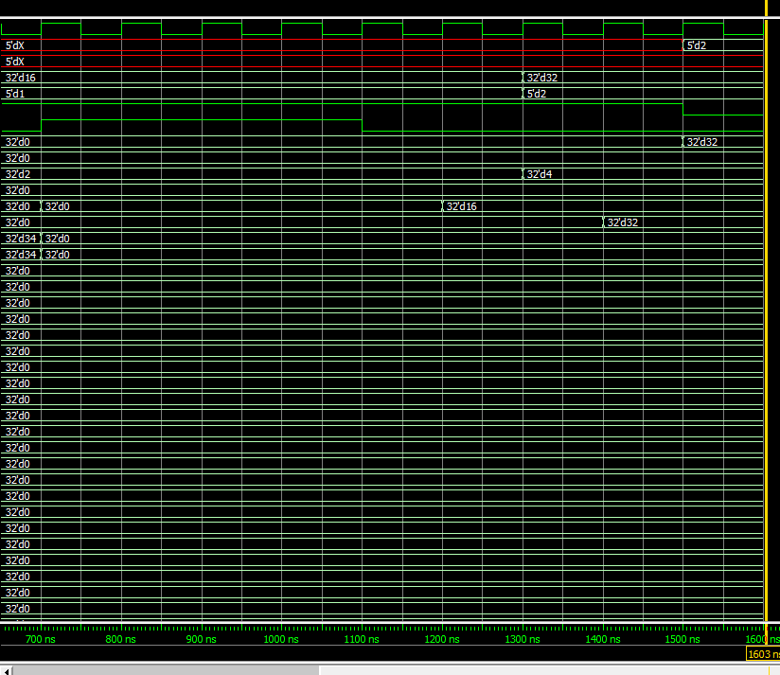

- [Part A.2] ALU: read through ALU.vhd and fill in the control table of operations (2 pts)

Control Value | ALU Operation
0000 | Addition
0001 | subtraction
0010 | XOR
0011 | NOR
0100 | NAND
0101 | AND
0110 | OR
0111 | Set less then
1000 | multiply
1001 | Shift right arithmetic
1010 | Shift right logical
1011 | Shift left logical

For screen shot the fourth line in is Addition: 2 + 3 = 5
For the 6th line in is subtracting 2-3 = -1
For the 7th line in is shifting shift right arithmetic
For the 8th line in is ANDing which is 2
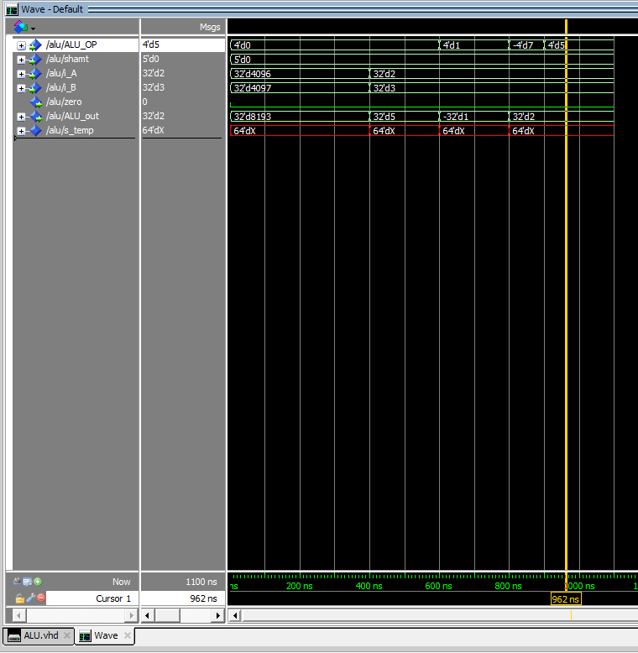

- [Part A.3.a] Memory: Modify the dmem.mif file to contain the values -1, 2, -3, 4, -5, 6, -7, 8, -9,10 starting from address 0. Include the modified dmem.mif snapshot. (1 pts)
- Screenshot of dmem.mif
- Attached the file instead of screenshot

- [Part A.3.b] Memory: Simulate mem.vhd and verify that the memory is initialized to the new values you’ve written in dmem.mif file. Provide a screenshot (1 pts)
- Screenshot showing that the ten values are loaded on memory starting from address 0
- 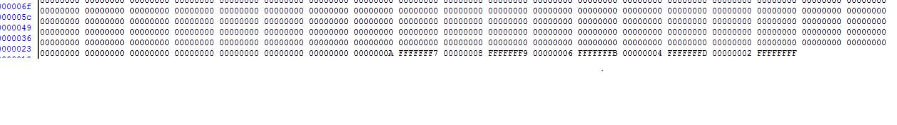

- [Part A.4.e] Simplified MIPS: Test ADDI, SUB, SLL, LW and SW(3 pts)
- ADDI
  - I was not able to get the actual unit to work but I understand what I am supposed to do. Took partial credit
  - Screenshot
  - Describe
    - What are the input values
    - what’s happening
    - by monitoring which signals, you convinced that it is working as intended
- SUB
  - reset <= '0'; reset is off
  - rs_sel <= "00010"; selecting register 2
  - rt_sel <= "00011"; register 3
  - reg_we <= '1'; write enable is on
  - w_addr <= "00001"; writing to register 1
  - reg_dest <= '1'; selecting the output of the ALU
  - Imm <= x"00000000"; don’t need this so zero
  - sel_imm <= '0'; select rt_data
  - ALU_op <= "0001"; this is the operation for subtract
  - shamt <= "00000"; don’t need this
  - mem_we <= '0'; write to the mem is off
  - At the end we will store r2-r3 in r1
- SLL
  - reset <= '0'; reset is off
  - rs_sel <= "00010"; selecting register 2
  - rt_sel <= "00011"; register 3
  - reg_we <= '1'; write enable is on
  - w_addr <= "00001"; writing to register 1
  - reg_dest <= '1'; selecting the output of the ALU
  - Imm <= x"00000000"; don’t need this so zero
  - sel_imm <= '0'; select rt_data
  - ALU_op <= " 1011"; this is the operation for shifting logical left
  - shamt <= "00000"; don’t need this
  - mem_we <= '0'; write to the mem is off
  - At the end we will store r2 << r3 in r1

- LW
  - reset <= '0'; reset is off
  - rs_sel <= "00010"; selecting register 2
  - rt_sel <= "00000"; register 0
  - reg_we <= '1'; write enable is on
  - w_addr <= "00001"; writing to register 1
  - reg_dest <= '0'; selecting the output of the Mem to load into reg
  - Imm <= x"00000000"; don’t need this so zero
  - sel_imm <= '0'; select rt_data
  - ALU_op <= "0000"; this is the operation adds R2+R0 to determine the value in MEM to load.
  - shamt <= "00000"; don’t need this
  - mem_we <= '0'; write to the mem is off
  - At the end we will store r1= MEM[r2]

- SW
  - reset <= '0'; reset is off
  - rs_sel <= "00010"; selecting register 2
  - rt_sel <= "00000"; register 0
  - reg_we <= '0'; write enable is off don’t need to write to reg
  - w_addr <= "00001"; writing to register 1 doesn’t matter
  - reg_dest <= '0'; does not matter
  - Imm <= x"00000000"; don’t need this so zero
  - sel_imm <= '0'; select rt_data
  - ALU_op <= "0000"; this specifiys where to write to in MEM => R2+R0
  - shamt <= "00000"; don’t need this
  - mem_we <= '1'; write to the mem is on
  - At the end we will store MEM[r2] = R0

- [Part B.5.ii] HI and LO registers (1 pts)
- Attach screenshots showing the register values after
  - A*B*C (also show the input values you entered and the output value you printed out on console)
  - A+B+C (also show the input values you entered and the output value you printed out on console)
  - (A+B+C)/A (also show the input values you entered and the output value you printed out on console)
  - 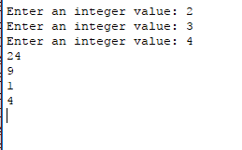
  - First is A*B*C
  - Then A+B+C
  - Then the remainder
  - Then the A+B+C / A

- [Part B.6.ii] Floating point arithmetic (1 pts)
- Attach screenshots showing
  - input values and output values showing on console
    - 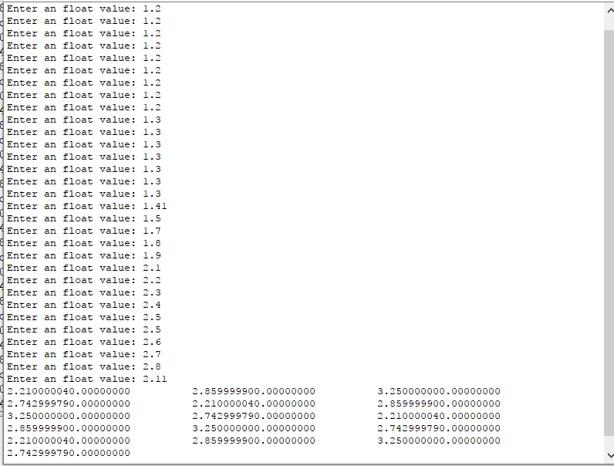
  - the final snapshot of the floating point registers
